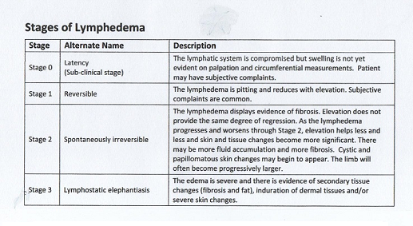

**What are the symptoms of possible Lymphedema?**

Suppose you had several lymph nodes radiated or removed from somewhere on your body. You are now at risk for getting Lymphedema (LE) at some point in your lifetime. Your immune system is also slightly weakened, so take care to stay healthy by avoiding sick people, eating well, exercising, and avoiding cuts to the skin.

Your doctor or nurses may not have told you about LE or what to watch for on your body if you start to get LE. Here are some early signs that may mean you need to go to a specialized lymphedema clinic (usually this means a PT clinic that employs a CLT: Certified Lymphedema Therapist).

* Heaviness in the limb that had lymph nodes damaged/removed
* Difficulty or stiffness bending the limb (elbow/knee/ankle)
* Pain in the limb
* Swelling in the limb, usually starting at the hands or feet and slowly moving up the limb
* In the arm, tightness where you wear rings, a watch, or around the band of a short-sleeved shirt
* An indentation remains at the place where you press on the skin